**Study Material**

**(Fuzzy Logic)**

**___________________________________________________________________________**

**Table of Contents**

|  |  |  |
| --- | --- | --- |
| **Module No.** | **Module Name** | **Content** |
| **Module 2** | **Fuzzy Logic** | Introduction to Fuzzy Logic |
| Fuzzy Sets and Membership Functions |
| Fuzzy Logic Operations |
|  |  | Fuzzy Arithmetic |

### 1. Introduction to Fuzzy Logic

#### 1.1 What is Fuzzy Logic?

Fuzzy Logic is a form of many-valued logic in which the truth value of variables may be any real number between 0 and 1, inclusive. It is a departure from the classic, crisp logic (Boolean logic) that has dominated for centuries.

* **Crisp Logic (Traditional Logic):**
  + Based on bivalence: a statement is either completely true or completely false.
  + Uses values of 1 (True) and 0 (False).
  + Example: A person is either "tall" (1) or "not tall" (0). There is a sharp, defined boundary. If the boundary is 6 feet, a person who is 5'11.9" is "not tall."
* **Fuzzy Logic:**
  + Deals with degrees of truth. A statement can be partially true and partially false.
  + Allows for modeling the kind of imprecise or vague reasoning that humans use.
  + Example: A person can be "somewhat tall," "very tall," or "not very tall." A person who is 5'11.9" might be considered "tall" to a degree of 0.95.

#### 1.2 A Brief History

* **Aristotle:** Laid the foundation for classical two-valued logic.
* **George Boole (19th Century):** Formalized binary logic, which is the basis for modern computers.
* **Lotfi A. Zadeh (1965):** Professor at UC Berkeley, introduced the concept of "fuzzy sets" and "fuzzy logic" in his seminal paper. He is considered the "father of fuzzy logic." He proposed it as a way to model the uncertainty of natural language.

#### 1.3 Why Do We Need Fuzzy Logic?

The real world is often ambiguous and imprecise. Human decision-making is not typically based on crisp, binary choices.

* **Handling Imprecision:** Many concepts we use daily are fuzzy: "hot" weather, "fast" car, "young" person. Fuzzy logic provides a mathematical framework to handle this vagueness.
* **Control Systems:** It is highly effective in control systems where the model is complex or unknown. Examples include:
  + Anti-lock Braking Systems (ABS)
  + Washing machines (adjusting water level and wash cycle based on "dirtiness" of clothes)
  + Air conditioners (maintaining a "comfortable" temperature)
* **Artificial Intelligence:** Used in expert systems, pattern recognition, and machine learning to create more "human-like" reasoning.

### 2. Fuzzy Sets and Membership Functions

#### 2.1 Fuzzy Sets

A fuzzy set is a set containing elements that have varying degrees of membership. In classical set theory, an element either belongs to a set or it does not. In fuzzy set theory, an element belongs to a set to a certain degree.

* **Crisp Set Example:** Let U be the set of people. Let A be the crisp set of "tall" people, defined as anyone with a height of 6 feet or more.
  + A person who is 6'1" is in set A.
  + A person who is 5'11" is not in set A.
* **Fuzzy Set Example:** Let B be the fuzzy set of "tall" people.
  + A person who is 6'1" might have a membership of 1.0 in set B.
  + A person who is 5'11" might have a membership of 0.9 in set B.
  + A person who is 5'5" might have a membership of 0.2 in set B.

#### 2.2 Membership Functions (μ)

A membership function maps each element of a universe of discourse (the set of all possible values) to a membership value (or degree of membership) between 0 and 1.

Let X be the universe of discourse. A fuzzy set A in X is defined by a membership function μA​(x) for all x∈X.

* μA​(x)=1 if x is completely in A.
* μA​(x)=0 if x is not in A.
* 0<μA​(x)<1 if x is partially in A.

#### 2.3 Types of Membership Functions

There are several common shapes for membership functions. The choice depends on the application and the nature of the concept being modeled.

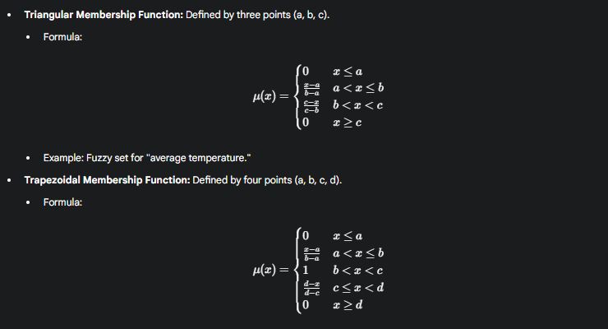

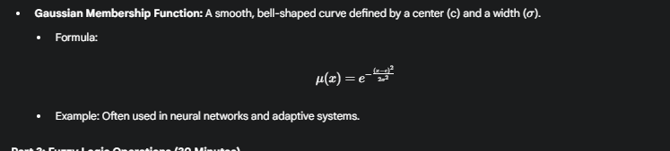

### 3. Fuzzy Logic Operations

Fuzzy logic uses operations analogous to Boolean logic's NOT, AND, and OR. These are defined using the membership functions of the fuzzy sets.

Let A and B be two fuzzy sets on the universe X.

#### 3.1 Complement (NOT)

The complement of a fuzzy set A, denoted as A', is defined as:

μA′​(x)=1−μA​(x)

* **Example:** If the membership value for "hot" is 0.8, the membership value for "not hot" is 1−0.8=0.2.

#### 3.2 Intersection (AND)

The intersection of two fuzzy sets A and B, denoted as A∩B, combines the sets by taking the minimum of their membership values. This is the most common definition (Zadeh's definition).

μA∩B​(x)=min(μA​(x),μB​(x))

* **Example:** Consider a decision for a smart fan: "If the temperature is **high** AND the humidity is **high**, then set the fan to **high**."
  + Let μhigh_temp​(x)=0.9
  + Let μhigh_humidity​(y)=0.7
  + The degree to which both conditions are true is min(0.9,0.7)=0.7.

#### 3.3 Union (OR)

The union of two fuzzy sets A and B, denoted as A∪B, combines the sets by taking the maximum of their membership values.

μA∪B​(x)=max(μA​(x),μB​(x))

* **Example:** Consider a rule for an irrigation system: "If the soil is **dry** OR the weather forecast is **sunny**, then water the plants."
  + Let μdry_soil​(x)=0.4
  + Let μsunny_forecast​(y)=0.8
  + The degree to which at least one condition is true is max(0.4,0.8)=0.8.

### 4. Fuzzy Arithmetic

Fuzzy arithmetic is an extension of standard arithmetic to fuzzy numbers. A fuzzy number is a fuzzy set that is both convex and normalized. They are often represented by triangular or trapezoidal membership functions.

Let's use triangular fuzzy numbers (TFNs) for our examples. A TFN is represented as A = (a1, a2, a3), where a2 is the peak and a1 and a3 are the endpoints.

#### 4.1 Addition of Fuzzy Numbers

If A = (a1, a2, a3) and B = (b1, b2, b3) are two TFNs, their sum is:

A+B=(a1+b1,a2+b2,a3+b3)

* **Example:** Let A be the fuzzy number "about 5," represented as (4, 5, 6). Let B be "about 10," represented as (9, 10, 11).
  + A+B=(4+9,5+10,6+11)=(13,15,17)
  + The result is a new fuzzy number, "about 15."

#### 4.2 Subtraction of Fuzzy Numbers

If A = (a1, a2, a3) and B = (b1, b2, b3) are two TFNs, their difference is:

A−B=(a1−b3,a2−b2,a3−b1)

Note the crossover of terms.

* **Example:** Using A = (4, 5, 6) and B = (9, 10, 11).
  + A−B=(4−11,5−10,6−9)=(−7,−5,−3)
  + The result is "about -5."

#### 4.3 Multiplication of Fuzzy Numbers

If A and B are two positive TFNs, their product is approximately:

A×B≈(a1×b1,a2×b2,a3×b3)

This is an approximation but is commonly used for simplicity.

* **Example:** Let A = "about 2" (1, 2, 3) and B = "about 4" (3, 4, 5).
  + A×B≈(1×3,2×4,3×5)=(3,8,15)
  + The result is "about 8," but with a wider spread, reflecting increased uncertainty.

#### 4.4 Division of Fuzzy Numbers

If A and B are two positive TFNs, their quotient is approximately:

A÷B≈(a1÷b3,a2÷b2,a3÷b1)

* **Example:** Let A = "about 10" (8, 10, 12) and B = "about 2" (1, 2, 3).
  + A÷B≈(8÷3,10÷2,12÷1)=(2.67,5,12)
  + The result is "about 5," again with a wide spread.

